

Early Brain Tumor Detection

# Final Year Project Report Submitted by:

**Dilbar Hussain (CMS-ID 023-20-0155)**

# Supervisor: Assistant Professor Zakriya Jamali

In Partial Fulfillment Of

The Requirements for the Bachelors of Science (CS)

# DEPARTMENT OF COMPUTER SCIENCE SUKKUR IBA UNIVERSITY

**(2024)**

# DECLARATION

I hereby declare that this project report entitled “**Early Brain Tumor Detection Web Based System**” submitted to the “**Department of Computer Science Sukkur IBA University**”, is a record of an original work done by me under the guidance of Supervisor Mr. Zakriya Jamali and that no part has been plagiarized without citations. Also, this project work is submitted in partial fulfillment of the requirements for the degree of Bachelor of Computer Science.

### Team Members Signature

Dilbar Hussain

### Supervisor: Signature

Mr. Zakriya Jamali

**Date:**

# DEDICATION

*“Don’t complain the darkness, Light a candle” I dedicate this work to the Vice Chancellor of Sukkur IBA University who lit the candle of education for millions of people by establishing this meritorious institute, Sukkur IBA University. My work is dedicated to*

**Mr. Nisar Ahmad Siddiqui - A Beacon of Light Founder of - Sukkur IBA University**

# ACKNOWLEDGEMENTS

I would like to all the people who have helped me along the way and contributed to this research. I am especially grateful to my Supervisor Mr. Zakriya Jamali for motivating me to achieve this milestone on time. I also thank the Department of Computer Science for empowering me and arranging FYP activities.

Finally, I would like to pay Tribute to the Visionary “Late Professor Nisar Ahmed Siddiqui” for lighting the candle in many students’ lives. I am indebted to all his services. I have learned how to pursue research problems with intellectual rigor and how to critically evaluate my work. Over the last two years, I have had the privilege of working with a variety of people who have made my time at Sukkur IBA University an enjoyable and intellectually stimulating experience.

Finally, I would like to acknowledge the endless love of my family, who have been a constant source of support and who have provided guidance, love and encouragement throughout my degree.

Thanks to every single soul of Sukkur IBA University.

**– Dilbar Hussain –**

Table of Contents

ABSTRACT 12

INTRODUCTION 13

1.1 Background 13

1.2 Project Goals 13

1.3 Project Scope 14

1.4 Not In Scope 14

1.5 Project Objectives 14

LITERATURE REVIEW 15

PROBLEM DEFINITION 21

METHODOLOGY 22

DETAILED DESIGN AND ARCHITECTURE 24

5.1 ARCHITECTURE DESIGN APPROACH 24

5.2 ARCHITECTURE DESIGN 25

5.3 SEQUENCE DIAGRAM 27

5.4 ACTIVITY DIAGRAM 28

5.5 FUNCTIONAL HIERARCHY 29

5.6 CLASS DIAGRAM 30

5.7 USE CASE DIAGRAM 31

IMPLEMENTATION AND TESTING 32

6.1 IMPLEMENTATION 32

6.1.1 Frontend (Web Application) 32

6.1.2 Backend 32

6.2 TESTING 33

RESULTS AND DISCUSSION 38

7.1 BACKEND MODEL 38

7.2 AI DERMASSISTANT WEB BASED SCREENS 50

CONCLUSION AND FUTURE WORK 56

8.1. CONCLUSION 56

8.2. RECOMMENDATIONS AND FUTURE DIRECTIONS 56

REFERENCES 57

# Abstract:

Brain tumors represent a significant health concern worldwide, with its diverse and complex nature necessitating advance detection, prevention, and doctor recommendation strategies.

This project investigates the multidimensional aspects of brain tumors, focusing on its early detection, and the essential role of physician recommendations.

The early detection of brain tumors is a critical task that enables accurate diagnosis and targeted treatment. This project examines the evolving landscape of brain tumor early detection techniques, ranging from traditional histopathological methods to cutting-edge molecular profiling. Furthermore, it explores the integration of Artificial Intelligence and Machine Learning in refining early detection accuracy, enabling personalized treatment plans and predicting patient outcomes. Prevention strategies for early brain tumors encompass a range of lifestyle modifications and risk factor management. It also emphasizes the significance of public health campaigns in raising awareness about risk reduction through measures like healthy dietary choices, minimizing radiation exposure, and fostering a tobacco-free environment. Effective doctor recommendation systems play a pivotal role in facilitating timely diagnosis and appropriate treatment.

Doctor recommendation and patients’ communication can be addressed by utilizing emerging technologies tools such as Telemedicine and Decision Support Systems (DSS) that not only enhance but also streamline the referral process.

In conclusion, the intricate landscape of early brain tumor detection, prevention, and doctor recommendation strategies. By embracing advancements in detection methodologies, adopting preventive measures, and optimizing doctor-patient interactions, the medical community can collectively enhance brain tumor management and patient outcomes. This project can further be extended for prevention, design for mobile applications and chatbot.

Keywords: brain tumors, detection, prevention, doctor recommendation, molecular profiling, artificial intelligence, risk factors, telemedicine, decision support systems.

# CHAPTER-1 INTRODUCTION

### Background

Artificial intelligence (AI) has emerged as a transformative force across numerous domains, revolutionizing the way we approach complex problems and make decisions. This technology leverages computational power and machine learning algorithms to analyze vast datasets and make predictions or classifications. One area where AI has shown remarkable promise is in healthcare, particularly in the early detection and diagnosis of life-threatening diseases. This thesis project focuses on the application of AI in the crucial domain of early brain tumor detection.

The adoption of AI in healthcare has covered the way for more efficient, accurate, and cost-effective solutions to long-standing medical challenges. From image analysis to predictive analytics, AI has proven its worth in revolutionizing patient care. In diagnostic medicine, AI systems have exhibited the ability to augment the skills of healthcare professionals, providing more precise and timely assessments of various conditions, from diabetes to cardiovascular diseases.

Brain tumors can occur at any age, and their effects are far-reaching. According to the American Brain Tumor Association (ABTA), approximately 90,000 primary brain tumors are diagnosed in the United States in every year. Globally, brain tumors are a significant cause of cancer-related morbidity and mortality. These tumors can be malignant or benign, and their clinical presentation can range from subtle symptoms to life-threatening neurological deficits. Consequently, early detection of brain tumors is paramount in improving patient outcomes, enhancing the quality of life, and reducing the economic burden of treating advanced-stage diseases.

The Proposed Solution Early Brain Tumor Detection Web Application is structured in a way that at the backend it has a machine learning model deployed. This model will take the image but before that preprocessing of the image will be done over the image. The image given to the model would present the detection results to the end users within seconds.

In Pakistan, when a patient goes to the hospital for a normal test and fees have been charged up to 15000 to 18000 per, and all the tests for brain tumors are very costly, how a normal family will pay? I am developing such a system in which he needs only the CT scan and MRI images, after that they can find whether he has a brain tumor or not, and my system will suggest it best workouts and eating suggestions and precautions and preventions by following that one can recover yourself from the brain tumor. My system will recommend to the best doctors who give treatment to the normal family up to 40% off. My project will minimize human error like sometimes doctors fails to identify the tumor when it is in early stages but system can find very easily and having good accuracy.

**1.2- Project Goals**

**Accessibility:** A common people can have access of the application using which he/she can classify Brain Tumor and also professional people like doctors and physicians can use this for the better results and for accuracy purposes. Now a days, even children’s know how to use web applications, they can detect yourself very well with good accurate results. World is going to technology very fast, we have to keep yourself updated will technology, now a days people take most of the answers from the google and treatment yourself. Early Brain tumor detection web-based systems helps them to detect early the Tumor by using smart phones and systems.

**Time Saving:** Brain tumor detection using web-based will consumes less time and it is an autonomous Web-based system for Brain tumor detection. Now a days, everyone working to do any task in very less time. People wants to shift yourself on technologies, technologies gives more accurate results than human and take very less time, time consumption less and accuracy very high.

**Rapid Results:** The Proposed idea can provide rapid results to the end user unlike the traditional methods. For that reason this idea has much weightage. Now a day, everyone wants rapid results, with high accuracy. In traditional methods, we are not sure about the accurate results within less time. Human can’t detect as accurately as a machine or model can detect.

**Training on a variety of datasets:** While training, one dataset brain-tumor-detection 2020 is used for detection. This dataset contains various types of brain tumor images. From different aspects, it shows tumor and model is using 80% of the percentage data for training and 20% for testing of the data. My model is working perfectly on the above dataset. I tried for the latest datasets on Kagle but I couldn’t find the latest one, so I used this one.

## 1.3– Project Scope:

As a minimum viable product, I have passed presented a product that would detect the Brain Tumor from CT scan or MRI image. For that user will have to get himself registered, then the user will be redirected to the login page. From the login page, the user will get redirected to the dashboard once the credentials get verified. From the dashboard, the user can upload the image and submit the response. At submitting the user response, the user gets the results of Brain Tumor detection. After that user can logout yourself.

## 1.4- Not In Scope:

This project will not store the detected images results to the database. This project doesn’t allow to capture image at runtime, it requires the user have images in device using which he access the web interface.

## 1.5- Project Objectives:

I am over to developing a system that provides accessibility to users for detecting Brain Tumor, and telling about the model used. The main objective is to get images as input and apply different techniques for image processing and machine learning model to detect brain tumor. The system would be thoroughly tested throughout the development cycle.

### Chapter Summary:

This chapter mainly discussed the background of the project, the scope and objectives of the project, the goal that must be achieved. And finally, the benefits achieved by the users through the web application.

## - Project Background

The Sukkur IBA University is a well-known educational institute located in the Sindh province of Pakistan. With a large number of students, faculty members, and administrative staff, the university faces many challenges in managing and organizing lost and found items on its campus. The current process for reporting lost or found items involves sending emails to various departments and waiting for a response. This process is often slow, inefficient, and prone to errors.

To address these challenges, the university has decided to develop a web-based lost and found service that will provide a convenient and efficient way for students, teachers, and administrators to report and search for lost items on the campus. This project aims to develop a user-friendly web application that will allow users to report lost or found items on the university campus, and search for lost items that have been reported by others.

The web application will be designed using database-connected web programming languages and will be built using the client-server model. The main functions of the web application will be to display a list of lost and found items, where users can enter information about lost and found items, and update the listed items if needed. The application will include an authentication, registration, and login system to ensure that only authorized users can access and use the system. The project is expected to be completed within a timeframe, and the web application will be hosted on the university's servers.

## - Project Objectives

The main objectives of this project are:

1. To provide a convenient and efficient way for students, teachers, and administrators of Sukkur IBA University to report lost or found items on the campus.
2. To develop a user-friendly web application that is accessible from anywhere using a web browser, without the need to install any software.
3. To ensure that the web application is secure and can only be accessed by authorized users.
4. To allow users to search for lost items that have been reported by others, and to update the status of their own lost or found items.
5. To streamline the process of managing lost and found items on the campus, reduce errors, and improve efficiency.
6. To ensure that the web application is scalable and can accommodate a growing number of users and items over time.
7. To provide a platform for the university to collect data on lost and found items, which can be used to analyze and improve the lost and found process in the future.
8. To provide a positive user experience and improve the overall satisfaction of users with the lost and found service provided by Sukkur IBA University.

## - Stakeholders

The stakeholders for this project are:

**Sukkur IBA University:** The University is the primary stakeholder as it is responsible for managing and maintaining the lost and found service. The success of the project will directly impact the university's reputation and the satisfaction of its students, teachers, and administrative staff.

**IT Department:** The IT department is responsible for initiating and overseeing the development of the lost and found service. They will work closely with the development team to ensure that the project meets the university's needs and requirements.

**Students:** Students are the primary users of the lost and found service and will benefit directly from the convenience and efficiency of the web application. They will be able to report lost or found items, search for lost items, and update the status of their own lost or found items.

**Teachers:** Teachers will also benefit from the lost and found service as they will be able to report lost or found items, search for lost items, and update the status of their own lost or found items.

**Administrative Staff:** Administrative staff will be responsible for managing and maintaining the lost and found service. They will be able to view and manage the reported items, update their status, and respond to user inquiries.

**System Administrators:** The system administrators will be responsible for installing, configuring, and maintaining the lost and found service on the university's servers. They will ensure that the web application is secure, stable, and performs well.

## - User Interfaces

[7] The external interface requirements for the user interface of the web-based lost and found service:

**Authentication, Registration and Login System:** The UI should have a clear and intuitive interface for users to register, login, and authenticate their identity.

**User Profile Management:** The UI should allow users to manage their profile by updating their contact information and changing their password.

**Lost and Found Item Listing:** The UI should have a page that displays a list of lost and found items, with clear and organized information about each item.

**Item Information Entry:** The UI should have a form for users to enter information about lost or found items, with clear fields and instructions.

**Item Update Functionality:** The UI should allow users to update information about listed items if needed.

**Administrator Access:** The UI should have a separate login for the administrator, with permissions to delete items and manage the system.

**User-Friendly Design:** The UI should be visually appealing, easy to navigate, and user- friendly to ensure a positive user experience.

**Compatibility:** The UI should be compatible with different web browsers and devices to ensure broad accessibility.

## - Hardware Interfaces and Software Interfaces

We would require the following technology for the development of the app:

* GPS Enabled Device
* Laptop/System

# CHAPTER-2 LITERATURE REVIEW

In this development, a system was created to return items to their owners. This product contains a document attaa ched to the product that contains a predefined identification number of the owner and a toll-free number. This prefix is sent from the caller to the reference point. Information Center to contact the owner. After the owner receives information about his lost property from the Information Center. The biggest drawback of this system is the Information Center, which is the third medium used for lost items recovery, sometimes their servers can crash which can cause more problems for the lost person. [4]

This is an automatic lost and found system called LINR, which avoids the problem by providing a brief description of the item entered by the finder, which is stored in the file text and includes communication with the owner about lost items. Product warning message. The lost property report also informs the reporting party of the language used in submitting the lost property report and may also include an indication of the region from which the lost property report originated. This system has many disadvantages. The biggest disadvantage of this system is that the owner does not know the status of his goods when he sends information about the lost goods after delivery, because this system eliminates the trouble line because all kinds of lost data are checked by the system. [5]

This is a simple web-based client-server site designed for school students to easily find lost items. The main functions of the application include identification, registration and login, as well as lost and found pages where users can access and view information about lost items. Due to some security issues users cannot delete an item because some users will delete that item to make a mess. This permission is granted only to administrators. The app also allows users to update the list of items as needed. Users can update contact information and change passwords. The system does not have a proper GUI. Owners and explorers cannot talk to each other directly. The main problem is that neither the owner nor the discoverer can add their address. [6]

# CHAPTER-3 REQUIREMENTS SPECIFICATIONS

## - FUNCTIONAL REQUIREMENTS

## - Reporting Lost & Found items

The system shall allow users to report lost and found items by filling out a form that includes a detailed description of the item, photo, and any additional information that may be relevant.

## - User Registration and Login

The system shall allow users to create an account by providing basic personal information and login credentials, including a valid university email address and a password. Users should be able to log in to the application using their registered email and password. The system should also provide the ability for users to reset their password if they forget it.

## – Searching for Lost & Found Items

The system shall allow users to search for lost and found items by entering keywords, date, or other identifying information about the lost item. The system shall also display the search results in an organized and easy-to-read format.

## 3.1.2 – Update Status

The system allow users to update their lost or found item status whether it is found or returned to owner.

## 3.1.2 – Admin Dashboard

The system shall provide an admin dashboard for administrators to manage user accounts, view reports, and access analytics.

## – NON FUNCTIONAL REQUIREMENTS

### – Usability

The system shall be designed to be user-friendly and easy to navigate. The system shall also provide clear and concise instructions for reporting and searching for lost items.

### – Security

The system shall be designed to protect user data and prevent unauthorized access. The system shall use secure protocols for user authentication and data transmission.

### – Performance

The system shall be designed to handle a large volume of user traffic without experiencing performance issues. The system shall also have a response time of less than 5-10 seconds for all user requests.

## CHAPTER-4 PROBLEM DEFINITION

## – Problem Description

This initiative addresses the problem of inefficiency at IBA University in Sukkur Kandhkot Campus and the complex process of searching for lost and found items. Currently, students and teachers rely on email sent to school students or teachers to report lost or found items; This can affect people who are not directly involved. The fact that this system does not have a user-friendly interface and a central system causes delays and problems in retrieving lost items.

To overcome these challenges, this project aims to improve the missing website marketing and visual service for IBA University Sukkur. Web applications will provide interactive user interfaces and support Web programming languages that connect to data to improve usability and usability. The application helps manage lost and found items effectively using the client-server model.

The main features of the web application include authentication, registration and login system where users can create an account and personally verify their identity with their CMS ID or school ID verified by email. Once logged in, users will access a page that displays the names of lost and found items and allows them to provide information about the items. However, to ensure security and prevent abuse, users will not be able to remove items. Only administrators have permission.

## – Solution

Develop a user-friendly web application for Sukkur IBA University Kandhkot Campus's lost and found service. Features include authentication, item submission, admin control, and user profile management, enhancing efficiency and convenience in handling lost items.

## CHAPTER-5 METHODOLOGY

### – Purpose

This chapter outlines the design methodology employed during the development of the Lost and Found Portal. It defines the purpose of the methodology and provides a list of requirements to test the final product's implementation and success.

### – Software Development Methodology

The development of the Lost and Found Portal followed a specific methodology to ensure the successful implementation of the project. The chosen methodology for this project was Agile Development, which proved to be highly beneficial given the nature of the application.

### – Agile Methodology

Agile methodology is widely recognized and frequently used in software engineering. It emphasizes agility and the ability to respond to changes quickly and efficiently. By adopting the Agile model, the development team was able to shape and complete the Lost and Found Portal effectively. [9]

The Agile methodology provided numerous advantages throughout the development cycle, including:

* Simplicity and ease of use: The Agile framework was straightforward and easy to implement, allowing the development team to focus on the project's objectives.
* Focus during development: The iterative and team-based approach of Agile development kept the team focused and aligned with the project goals.
* Flexibility for changes: Agile allowed for changes to be made at any stage of development, accommodating evolving requirements and enhancing the final product.
* Effective project management: Agile provided a better methodology for controlling the entire project development process, ensuring efficient progress and management.

The Lost and Found Portal was developed using Agile sprints, which allowed for iterative development and continuous improvement. This approach encourages effective collaboration, frequent feedback and timely updates to ensure that the portal meets the specific requirements of the Sukkur IBA University Lost and Found System.

By following the agile process, the development team achieved Found Portal, a lost and found management system that meets expectations and provides effective solutions for managing lost and found items in the school community.

## - Use Case Diagram

To better manage our system requirements, we make use of a methodology that's called use case. The use case details how the user interacts with the system in different circumstances and focuses on a specific goal. [11]

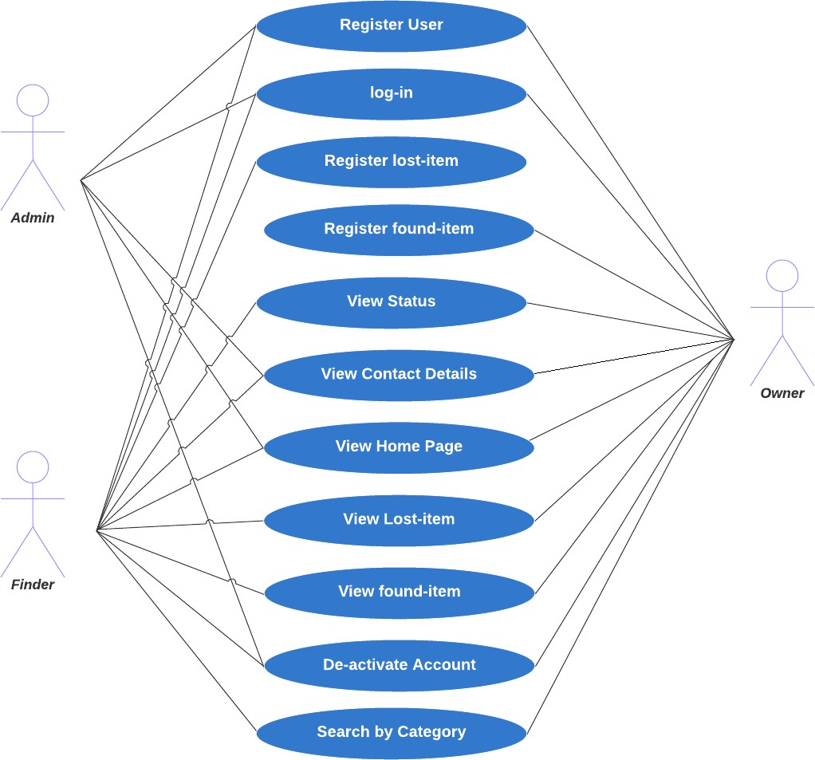

## - Flowcharts

When designing the layout of our web application, a common principle involved is using an activity diagram: It shows users interacting with the project by illustrating a workflow. This representation will have an initial point and a final outcome.

## Report lost item

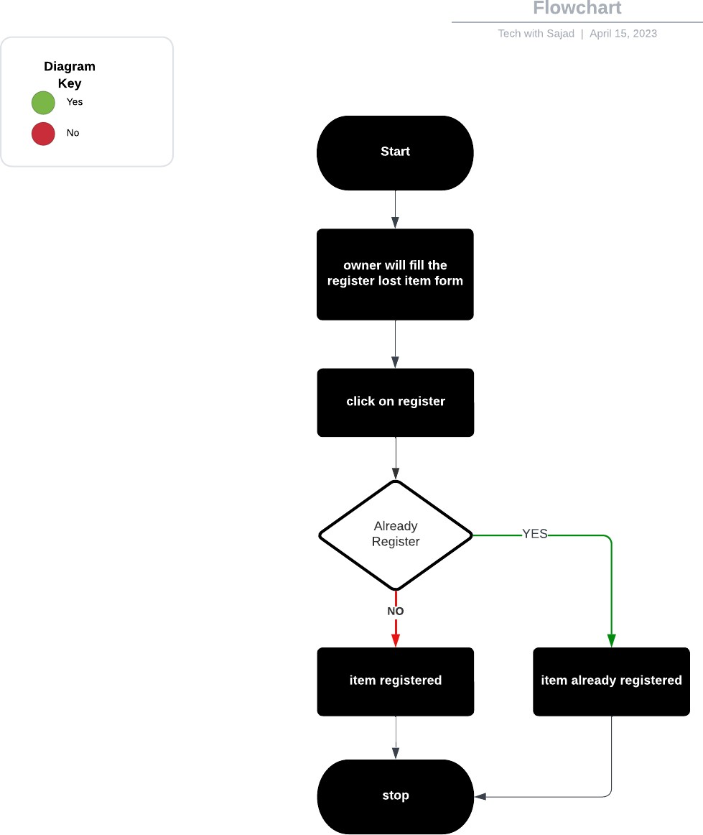

## Report found item

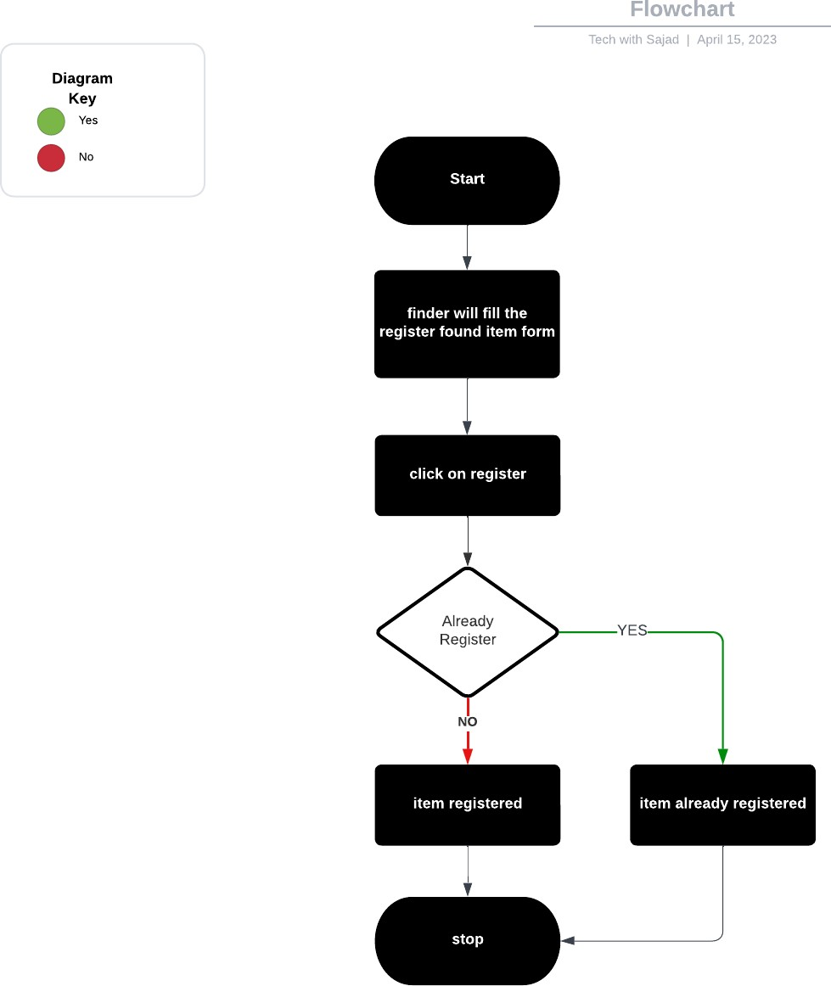

## Search by category

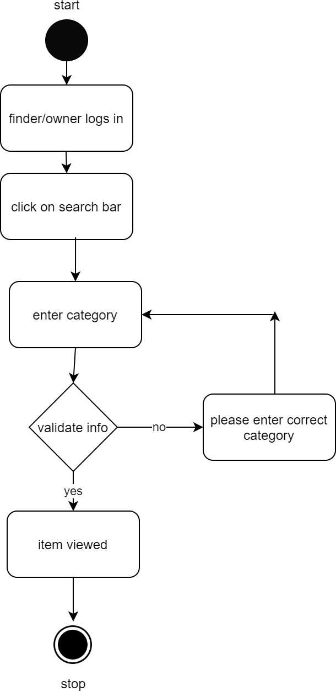

## View Statistics

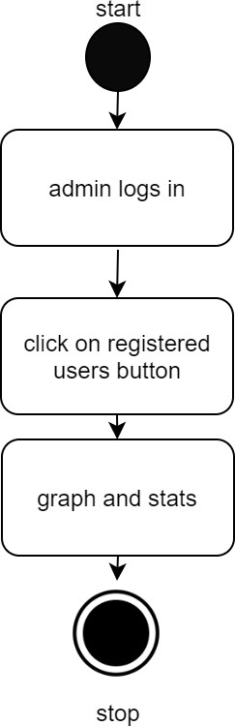

## - Class Diagram

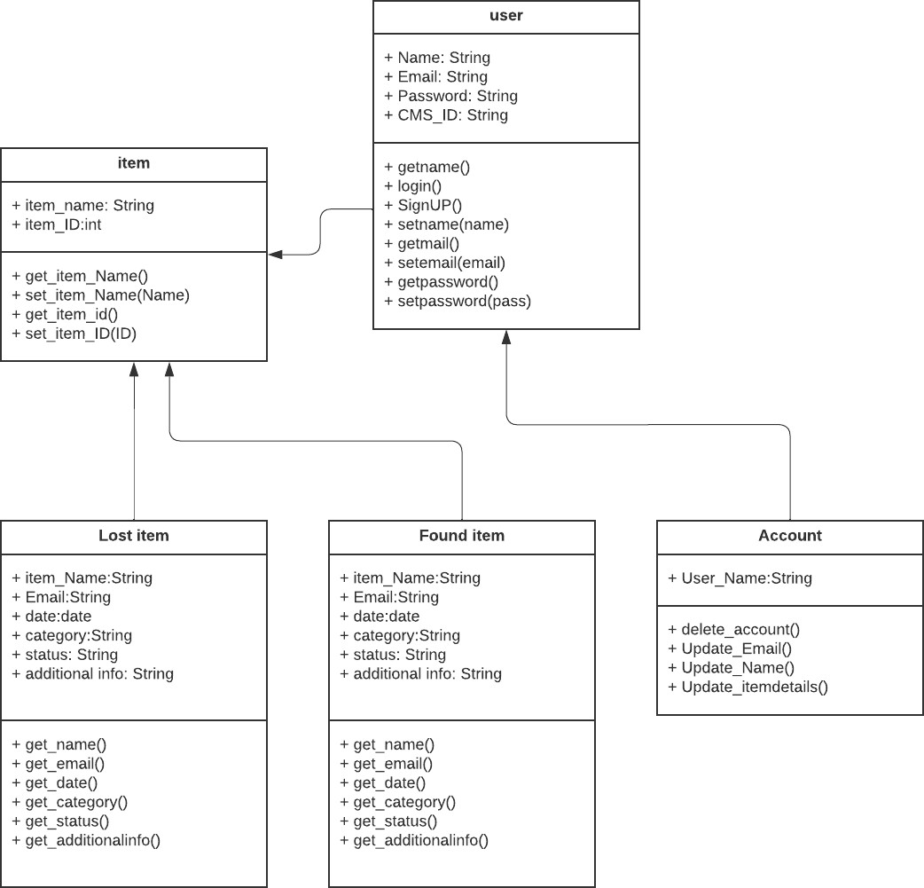

* 1. **- Sequence Diagrams**

### Login

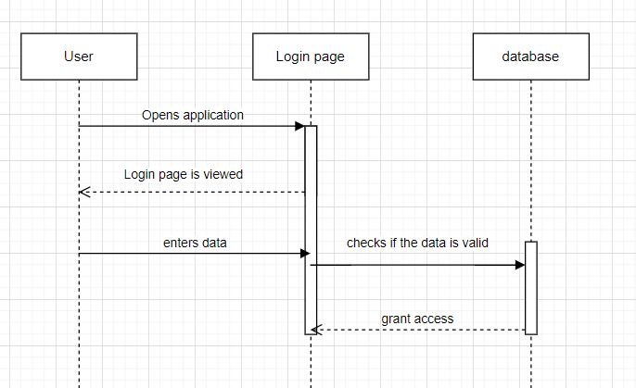

**5.7.1 Report lost item**

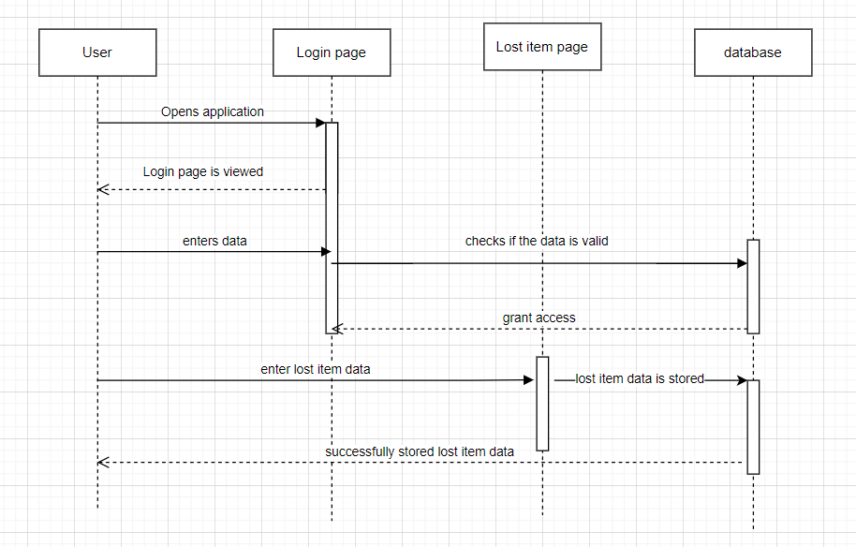

### 5.7.1 Report found item

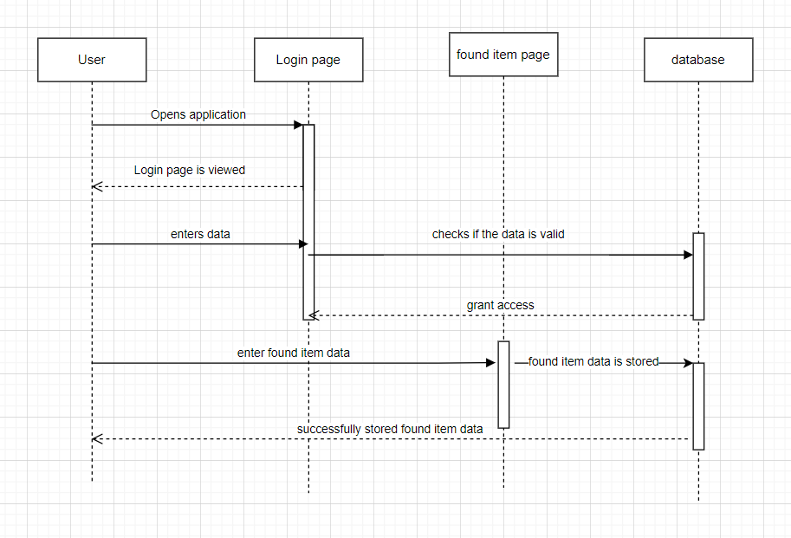

* 1. **- Entity Relationship Diagram**

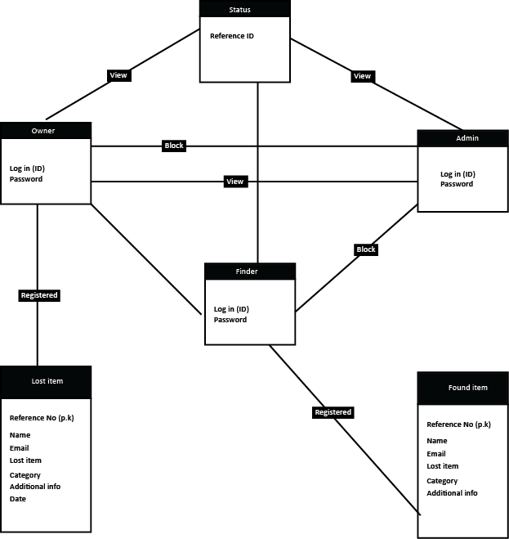

## CHAPTER-6 SYSTEM ARCHITECTURE

## 6.1 System Architecture

The system architecture of Sukkur IBA University's web-based decentralized drop-and- see program follows the client-server model. Client components include web browsers, user interfaces (UIs), and authentication modules. On the server’s side, there are web servers, application logic, databases, and server-side scripts. A database management system (DBMS) manages data storage and retrieval. Integration with external services such as email services and CMS/university identity systems. This model ensures security, efficient data management and efficient communication between clients and servers. [11]

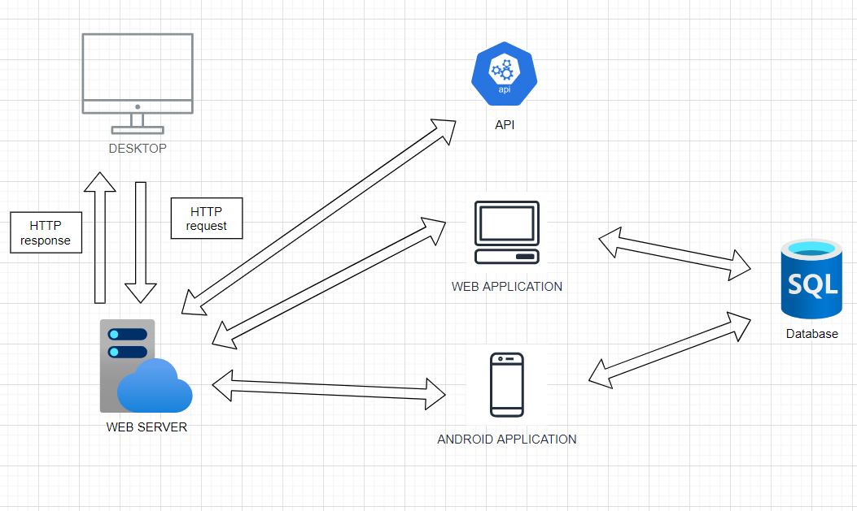

## CHAPTER-7 IMPLEMENTATION AND TESTING

### – Platform

The system shall be a web application that is accessible from any modern web browser.

### – Database

The system shall use a relational database to store user data, lost item reports, and search queries.

### – Programming, Frameworks, & Tool

The system shall be developed using the following programming languages and frameworks: HTML, CSS, Bootstrap, JavaScript, PHP, & MySQL.

### Tools:

GTMetrix for Performance & testing tools for web [8]. VS Code

Adobe Illustrator, Development Environment,

## CHAPTER-8 RESULTS AND DISCUSSION

In this section of this report, I am discussing the results after implementing my Lost & Found web app with the technologies I mentioned in the implementation section. I made all in one app for different roles of the application. This app authenticates different roles and shows the respective content for them. Let's see the screens of different roles.

### 8.1 – Login Screen

This screen is the main login in the web app. This will take your credentials and take them to the respective content and per the role of the user.

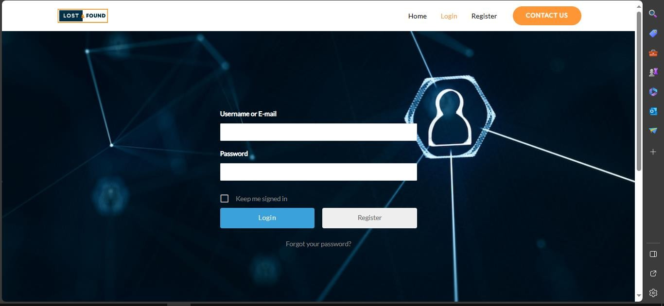

### 8.2- Signup Screen

The screens below is the process for the user signup which takes the details from the user and saves it to the database. The screens will lead the user to the Homepage if signup is successful and will show the successful message if the account is created and redirected to the user profile.

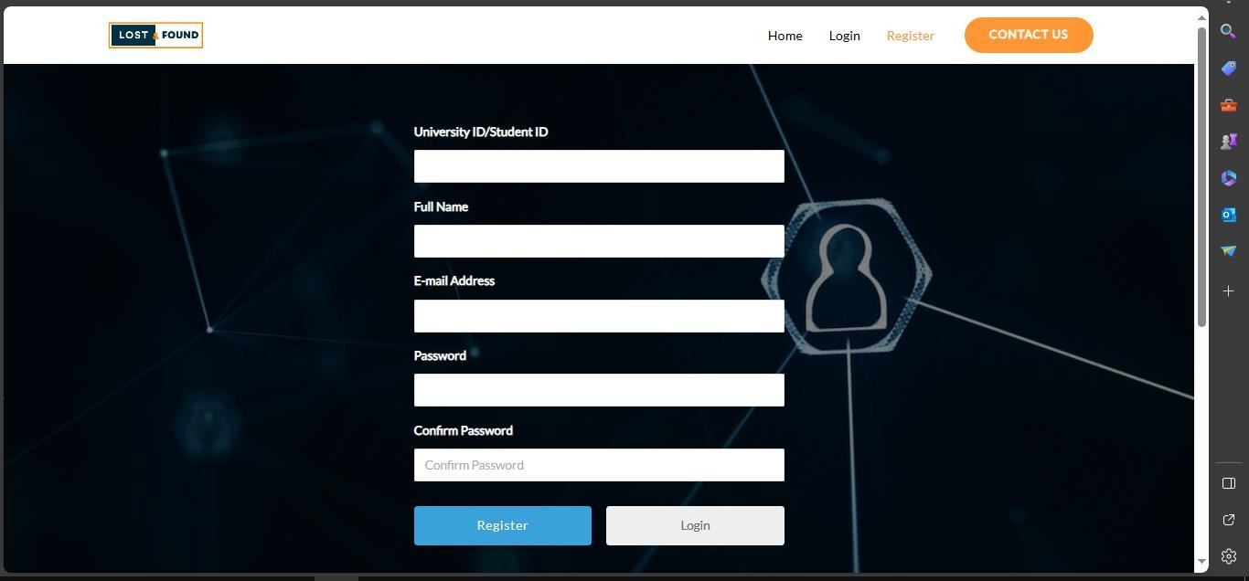

### – Home Screen

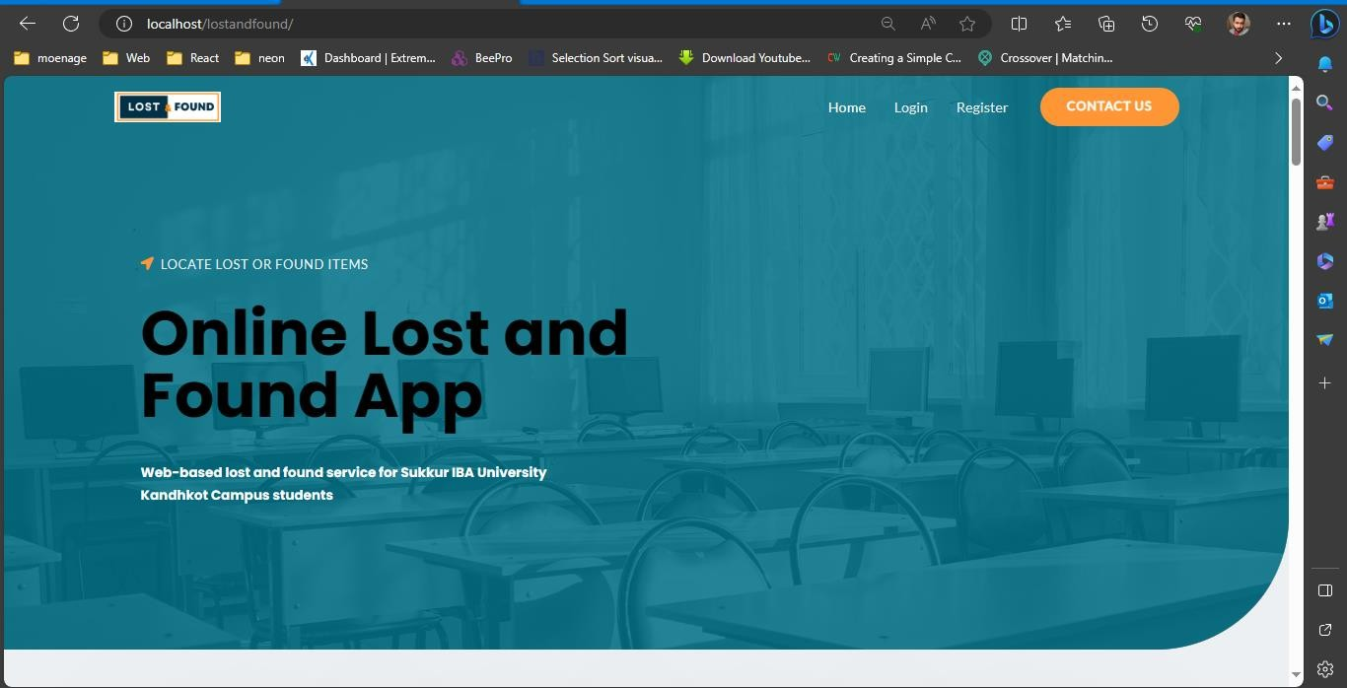

* 1. **– Profile Screen**

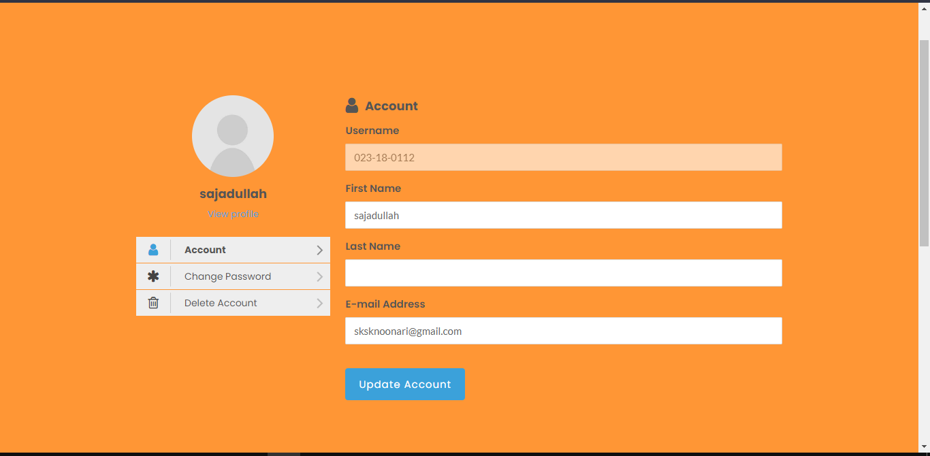

### – Reset Password Screen

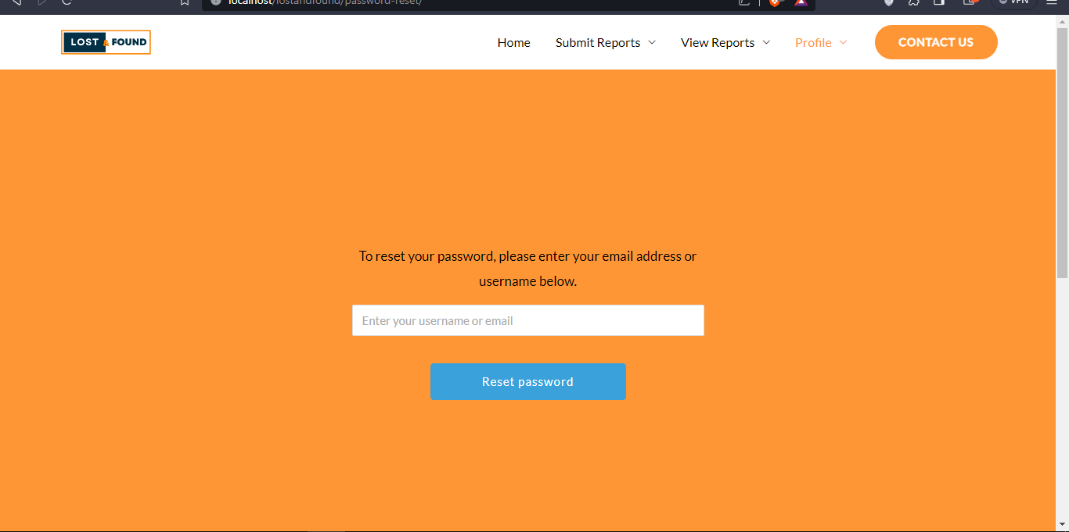

* 1. **– Contact Us Screen**

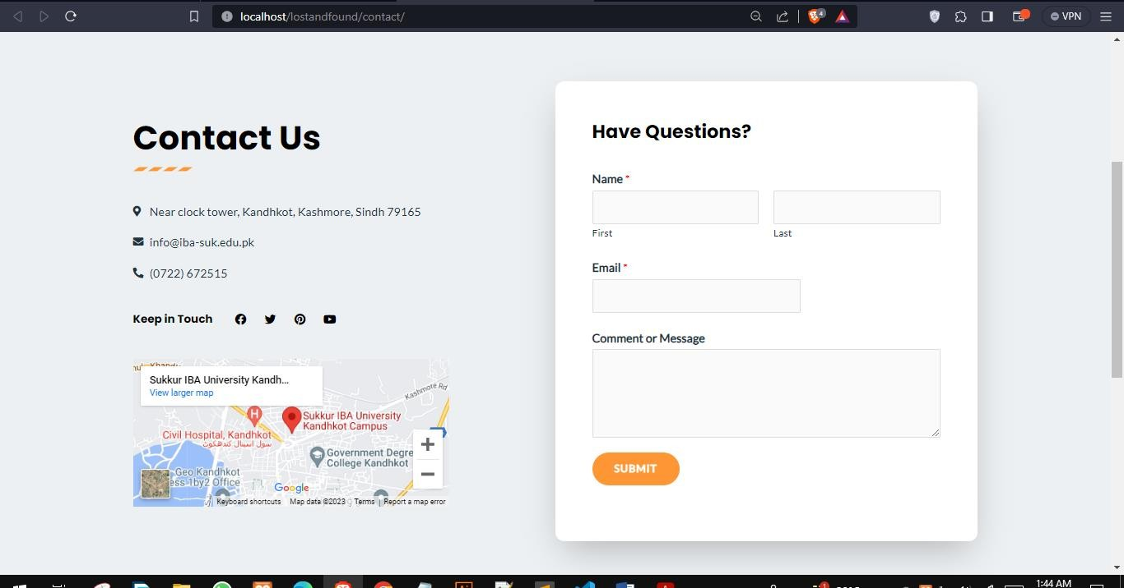

### – Footer Screen

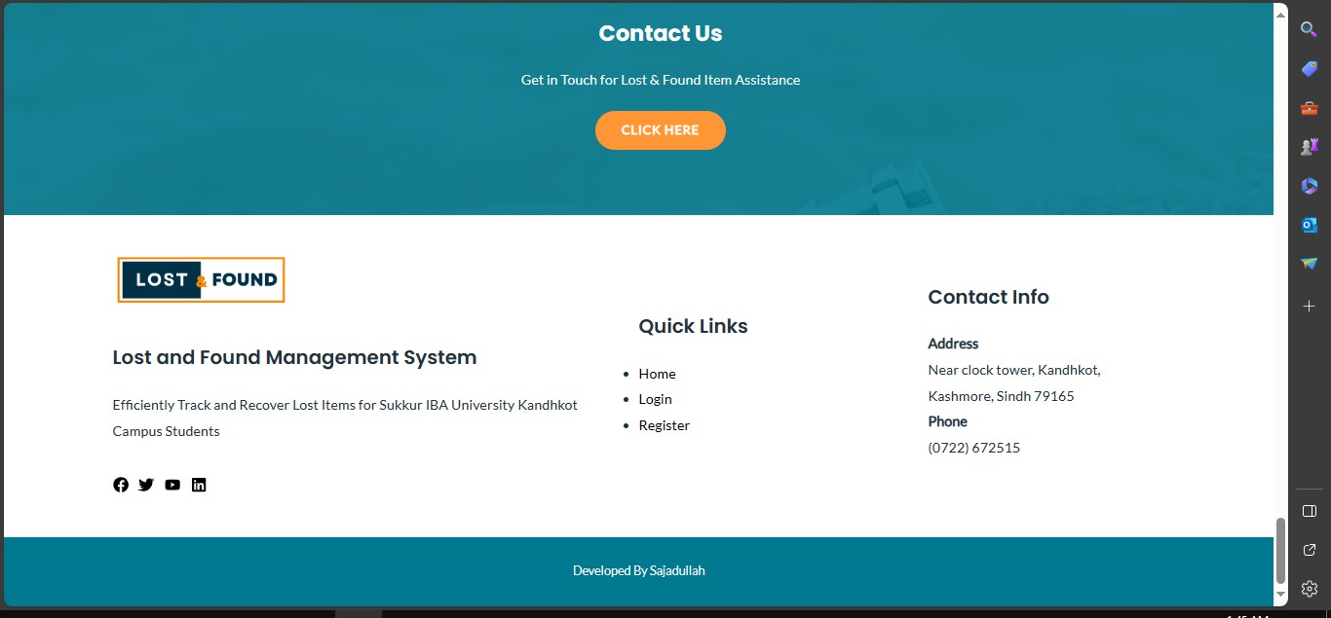

* 1. **– Submit Lost Form Screen**

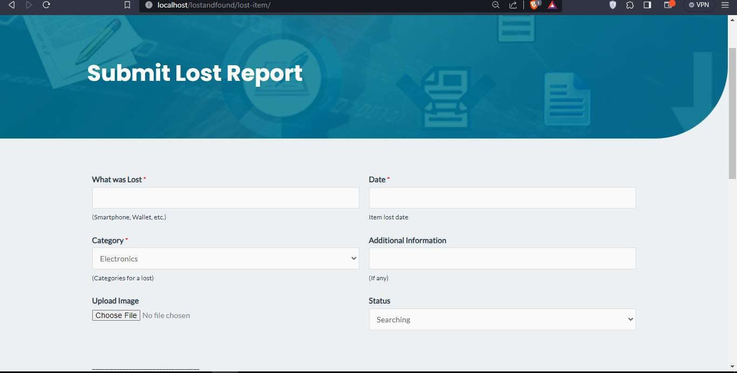

### – View Lost Item Screen

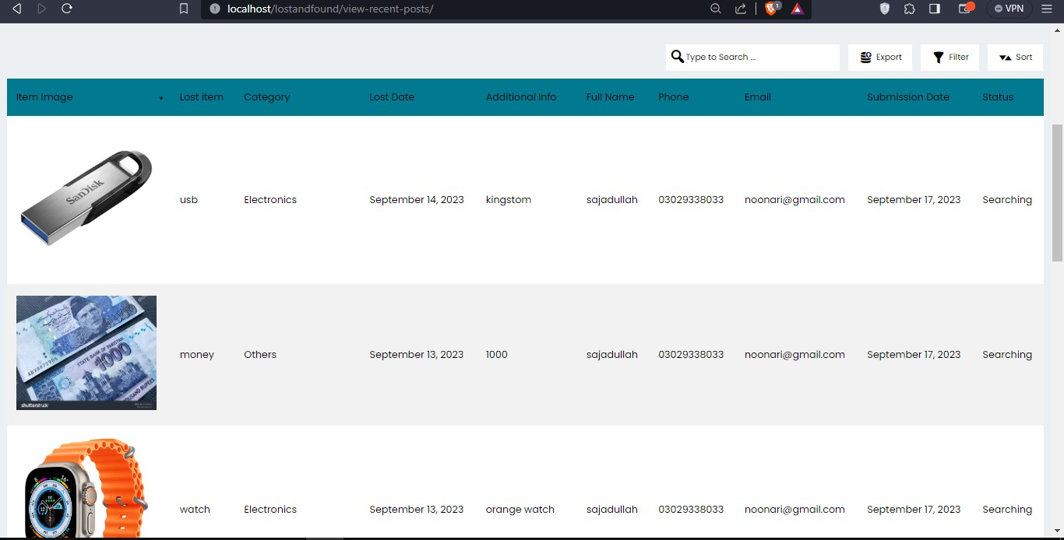

* + 1. **– Submit Found Form Screen**

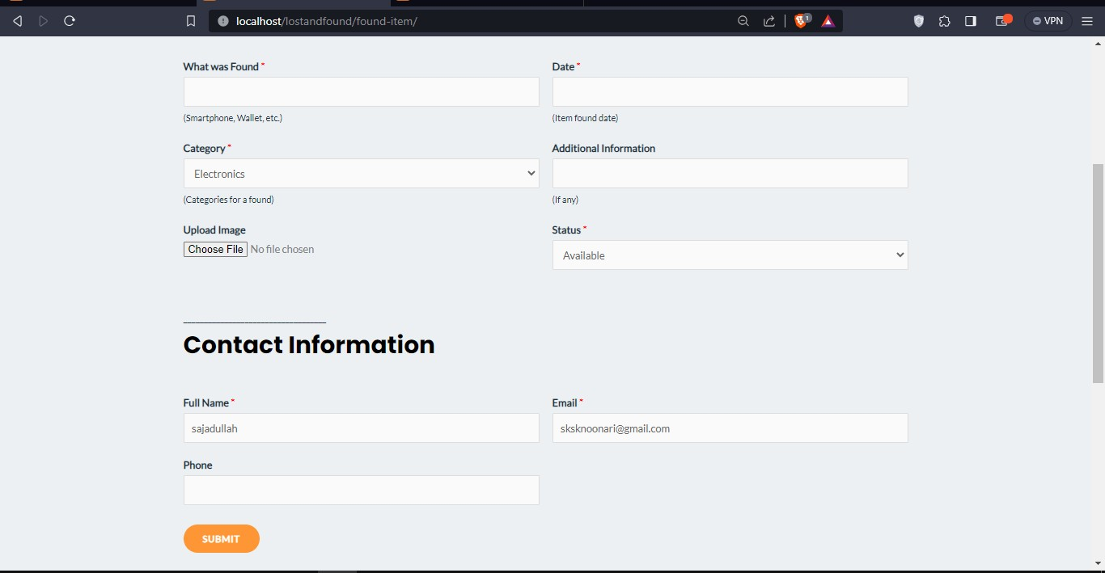

### – View Found Screen

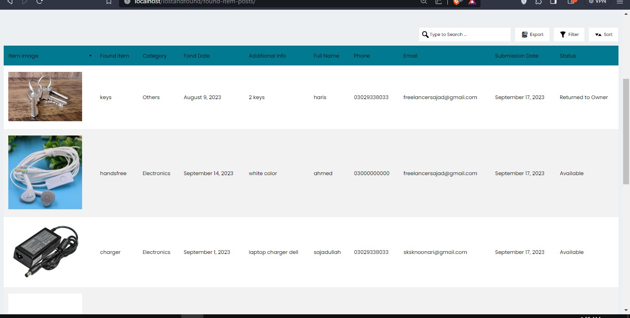

**8.9.2 – Home Page Section No.2**

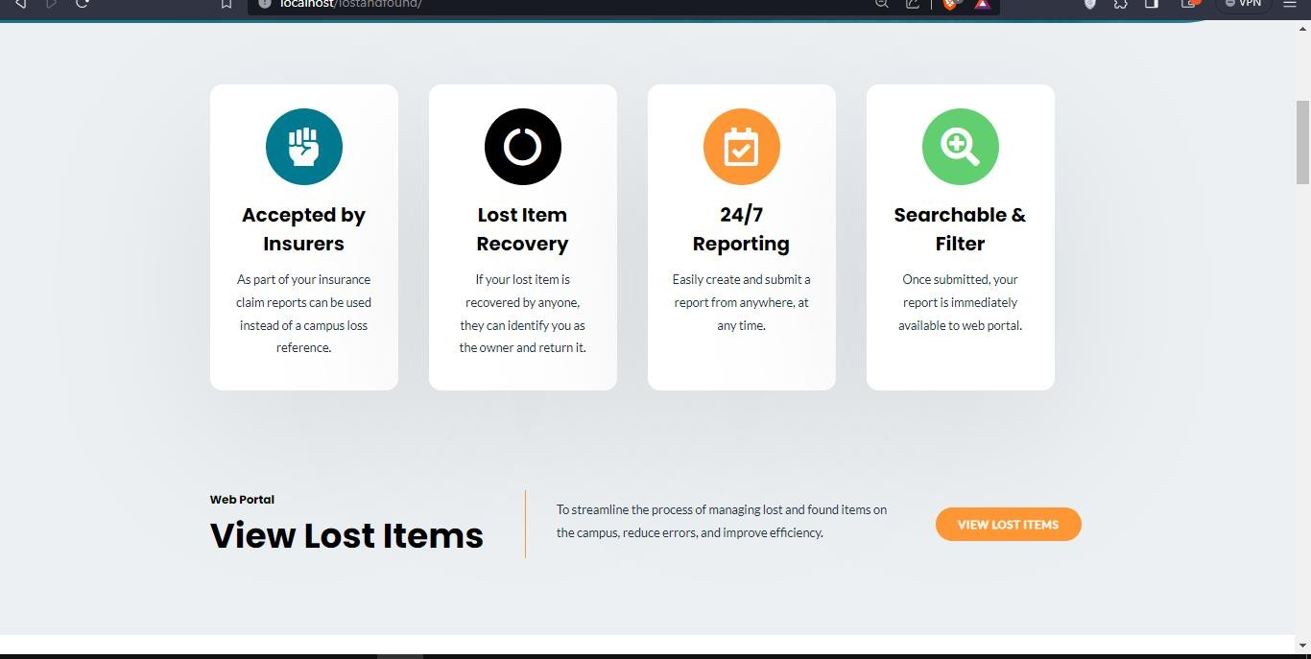

### – Home Page Section No.3

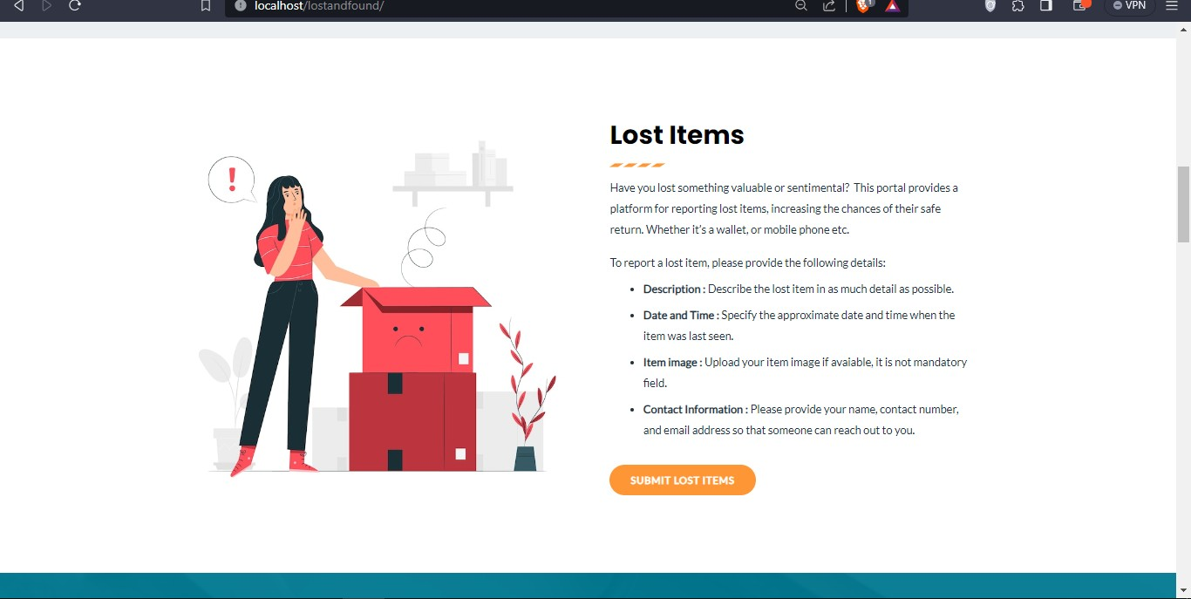

* + 1. **– Home Page**

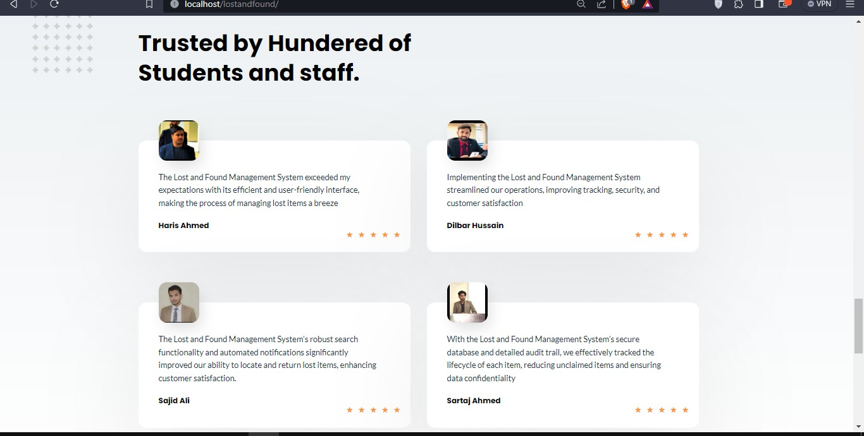

### – Entries (Dashboard)

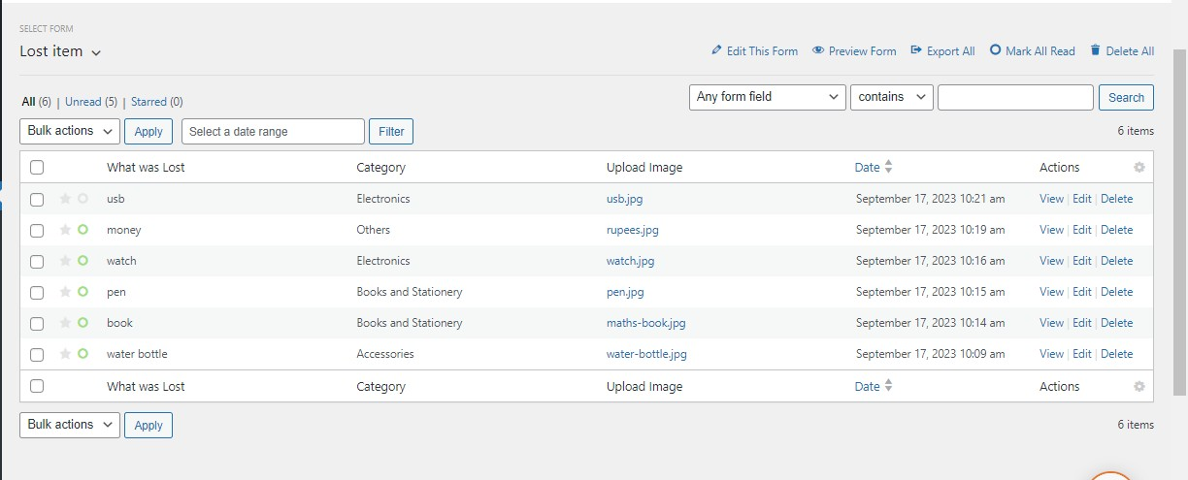

* + 1. **– View and Edit Single Entry (Admin side)**

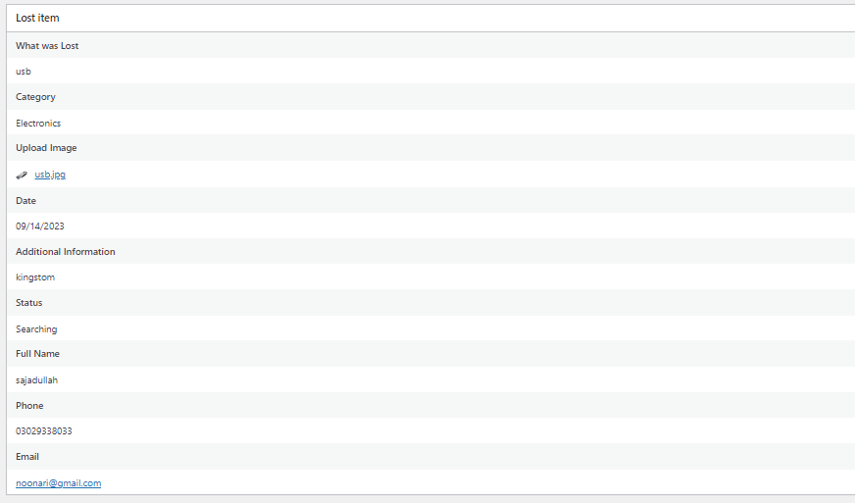

### – Reports Statistics

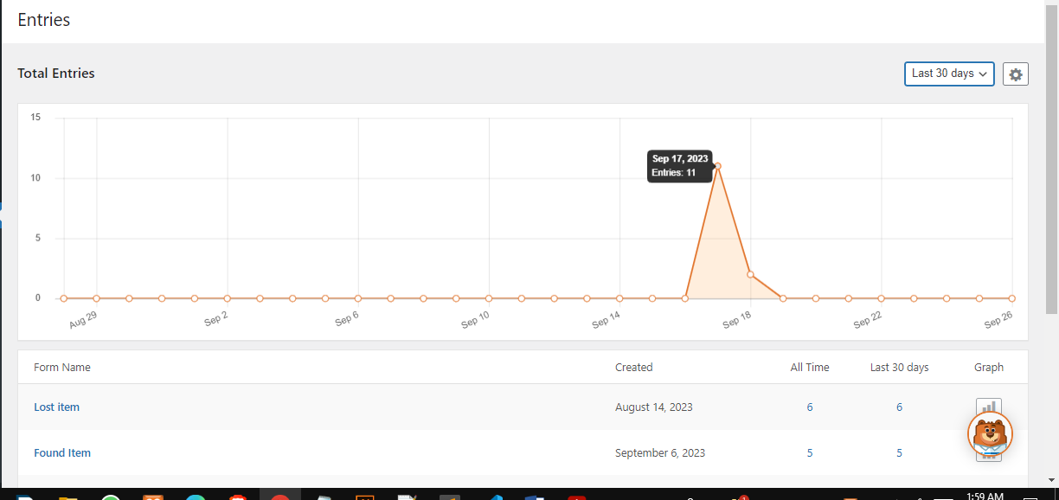

* + 1. 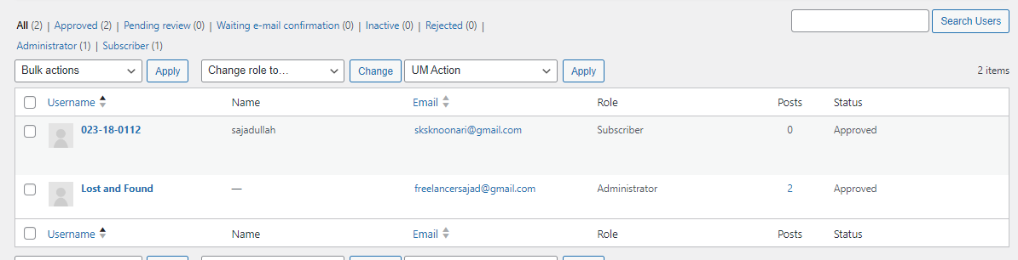**– Manage Users**
       1. **– Website Performance**

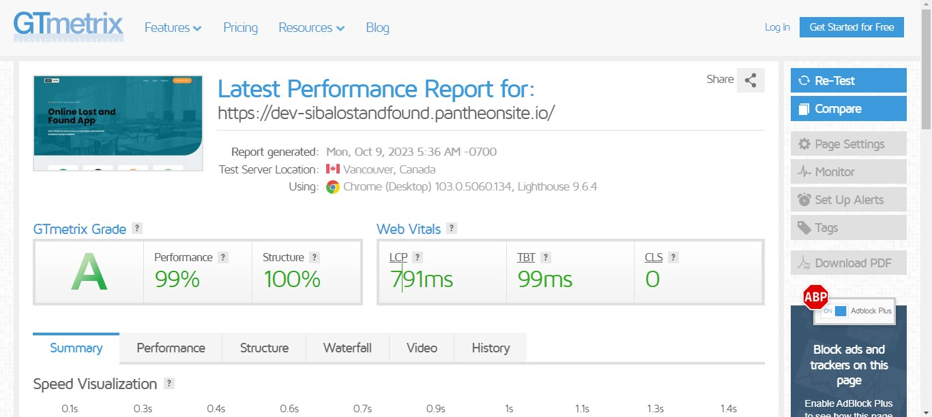

## CHAPTER-9 CONCLUSION & FUTURE WORK

## 9-1 Conclusion

To achieve this, this Final Year Plan (FYP) focuses on improving the missing web marketing and visual services of IBA University Sukkur. The aim of the program is to provide students and teachers with a simple and effective solution to finding lost and found items on campus. Using web services, the application allows users to access the portal from anywhere using a web browser, eliminating the need to install software.

The web application is designed with a user-friendly interface and uses the data link web programming language. The application follows the client model and includes basic functions such as authentication, registration and logging into the system. Users can submit information regarding lost and found items, resulting in a comprehensive list being displayed on the portal. To ensure security, users are prohibited from removing items; these permissions are reserved for administrators to prevent abuse.

In addition, the application allows users to update their contact information, change their password and delete their account if necessary. Simplify registration with CMS ID or University ID and ensure authenticity with email verification.

The main purpose of this web application software is to reduce the frustration of receiving a large number of emails in the emails of students and teachers. It may be a problem for people who are not involved in the lost property service.

By creating solutions on this website, it is expected that the school community will benefit from a collaborative and practical approach to advertising and finding lost and found items. The project ensured the effectiveness of web applications to improve management processes in schools and improve user experience. Improvements and advances may be made in the future to further improve the process and meet the changing needs of higher education institutions.

## Future Work

### - User Feedback and Ratings

Incorporate a feedback system where users can provide ratings or reviews for successful matches or interactions, helping to establish trust within the community.

### - Integration with External Services

Explore integration with other relevant services, such as local authorities, transportation companies, or community organizations, to enhance the effectiveness of the lost and found portal.

### - Item Matching Algorithm:

Develop an algorithm that matches lost and found items based on their descriptions, location, and other relevant information, helping users find potential matches more easily.

### - Messaging Applications:

A potential area of future work is the implementation of an Item Verification and Claim Process. This process aims to establish a secure mechanism for verifying the ownership of items and enabling users to claim their lost possessions.

## CHAPTER-10 REFERENCES

1. G. Coulouirs, J. Dollimore, T. Kindberg, “Distributed Systems Concepts and Design”,

*Addison-Wesley*, 2001.

1. Alexandru Dan Caprita, Vasile Mazilescu, “Web-Based Distributed Database Systems”, *Economy Information I-4*, 2005.
2. University Enrollment Information, “*htt*[*ps://w*](http://www.cpp.edu/~irar/just-the-)*ww.c*[*pp.edu/~irar/just*](http://www.cpp.edu/~irar/just-the-)*-*[*the-*](http://www.cpp.edu/~irar/just-the-) *facts/university-enrollment.shtml*”.
3. Method And System For Retrieval Of Lost Goods https://patentimages.storage.googleapis.com/41/16/cf/90c15ba9a32ccb/US6546088.pdf
4. Lost Item Notification And Recovery System https://patentimages.storage.googleapis.com/7a/d4/d3/8c606eeb77f89a/US20080079581 A1.pdf
5. Lost And Found Web Application For Cal Poly Pomona Students [http://dspace.calstate.edu/bitstream/handle/10211.3/194123/KaurHarkamal_Project2017.](http://dspace.calstate.edu/bitstream/handle/10211.3/194123/KaurHarkamal_Project2017) pdf?se quence=3
6. HCI for website user interface

[https://www.researchgate.net/publication/325534924_A_Review_Paper_on_Human_Co](https://www.researchgate.net/publication/325534924_A_Review_Paper_on_Human_Computer_Interaction) [mputer_Interaction](https://www.researchgate.net/publication/325534924_A_Review_Paper_on_Human_Computer_Interaction)

1. Website speed optimization https://gtmetrix.com/
2. Agile Methodology

[https://www.researchgate.net/publication/267706023_Agile_Processes_and_Methodologi](https://www.researchgate.net/publication/267706023_Agile_Processes_and_Methodologies_A_Conceptual_Study) [es_A_Conceptual_Study](https://www.researchgate.net/publication/267706023_Agile_Processes_and_Methodologies_A_Conceptual_Study)

1. Tool for Diagrams <https://lucid.app/documents>
2. Research paper for system architecture <https://www.sciencedirect.com/journal/journal-of-systems-architecture>
3. VS Code for coding IDE <https://code.visualstudio.com/>
4. Illustrator for Graph/Diagram https:/[/www.adobe.com/produ](http://www.adobe.com/products/illustrator/free-trial-download.html)c[ts/illustrator/free-trial-download.html](http://www.adobe.com/products/illustrator/free-trial-download.html)